**Proyek ISYS6677003**

**Sistem Informasi - Alerty**

Kelas : LL11

Kelompok : 14

Anggota :

* Derren Richard Nathanael / 2702251232
* Kennedy Surianto / 2702252525
* Elsa Amalia Berta / 2702272741
* Revandy William Lam / 2702220132



BINUS UNIVERSITY

Alam Sutera

Ganjil 2024/20245

**1. Activity Diagram**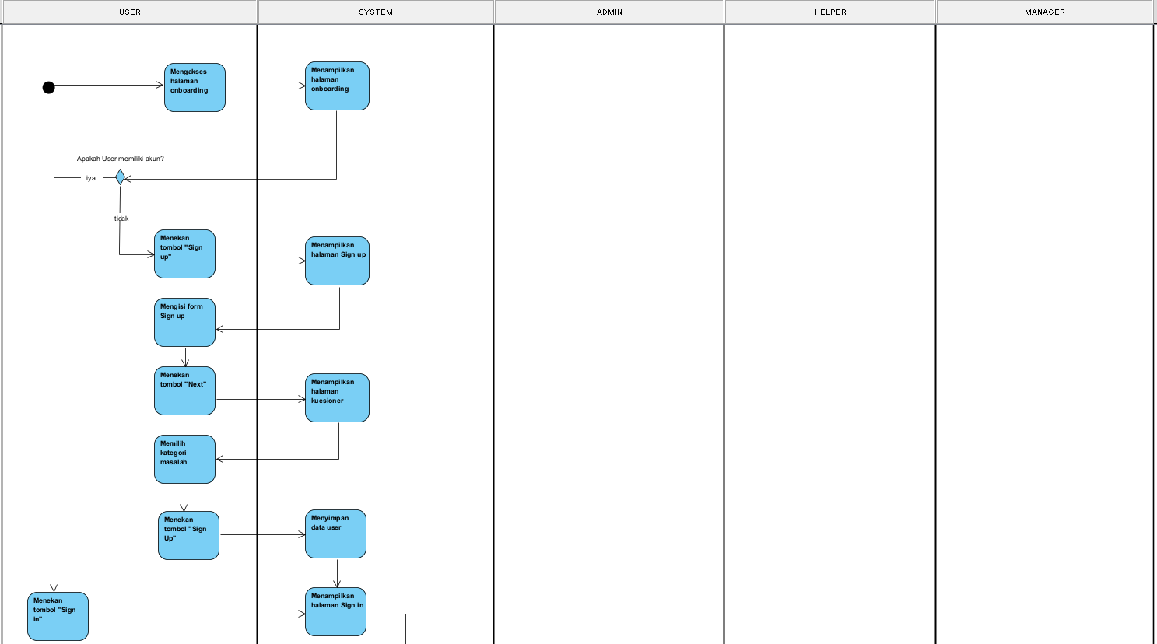

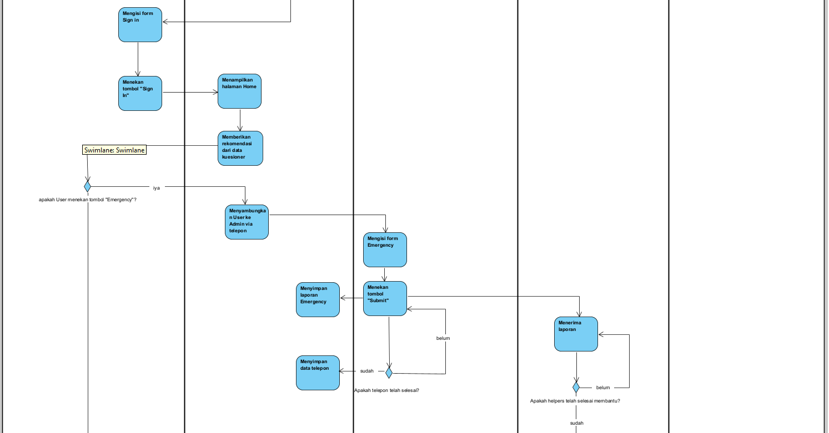

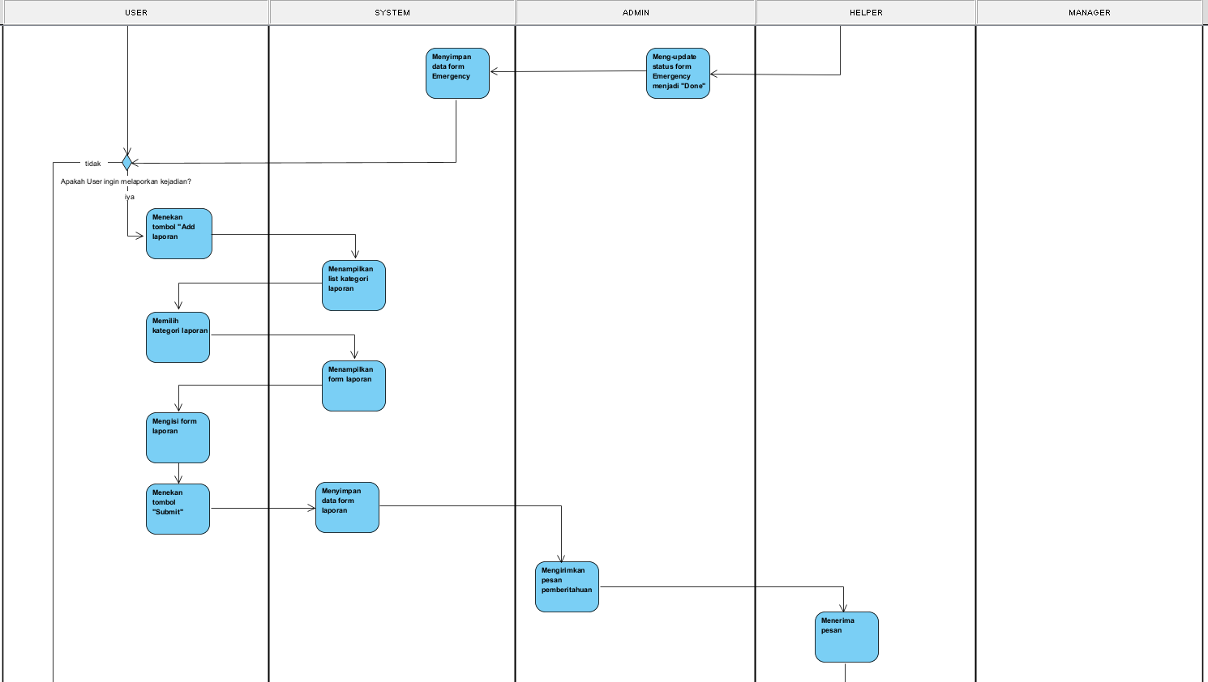

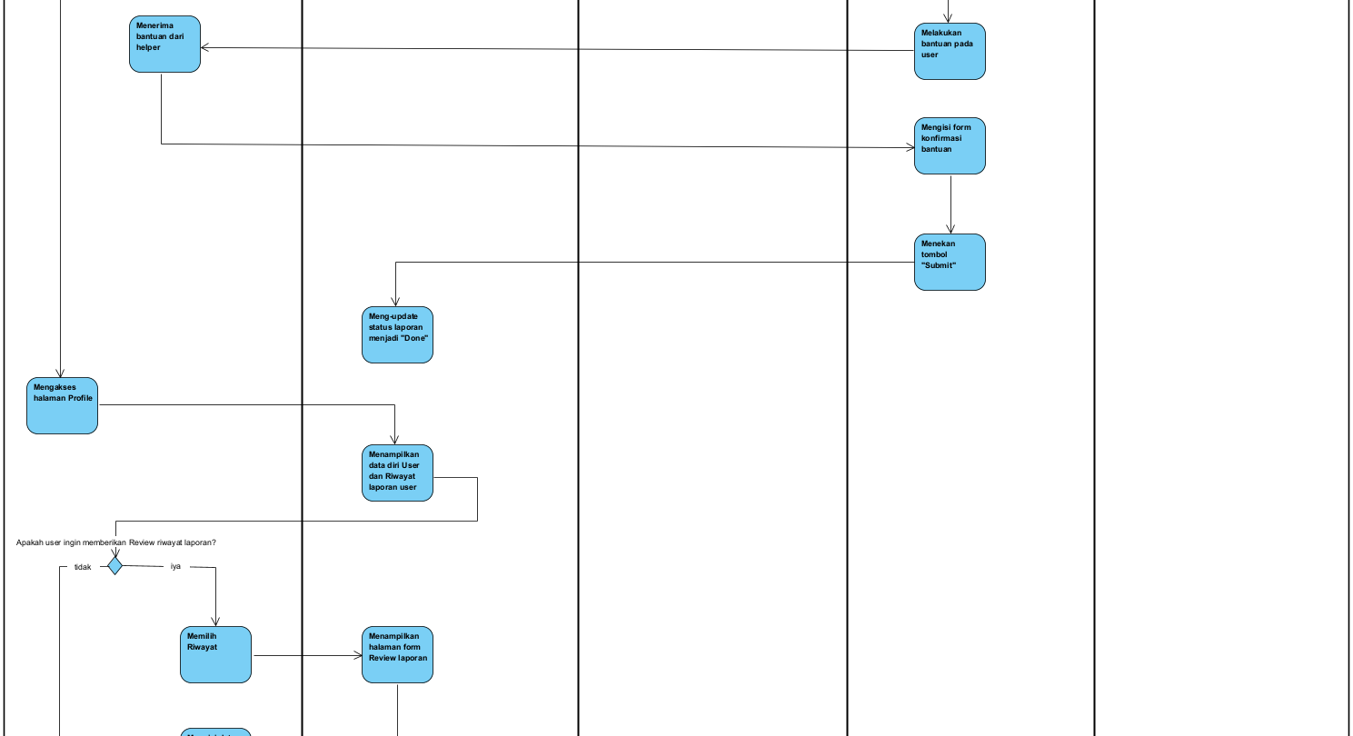

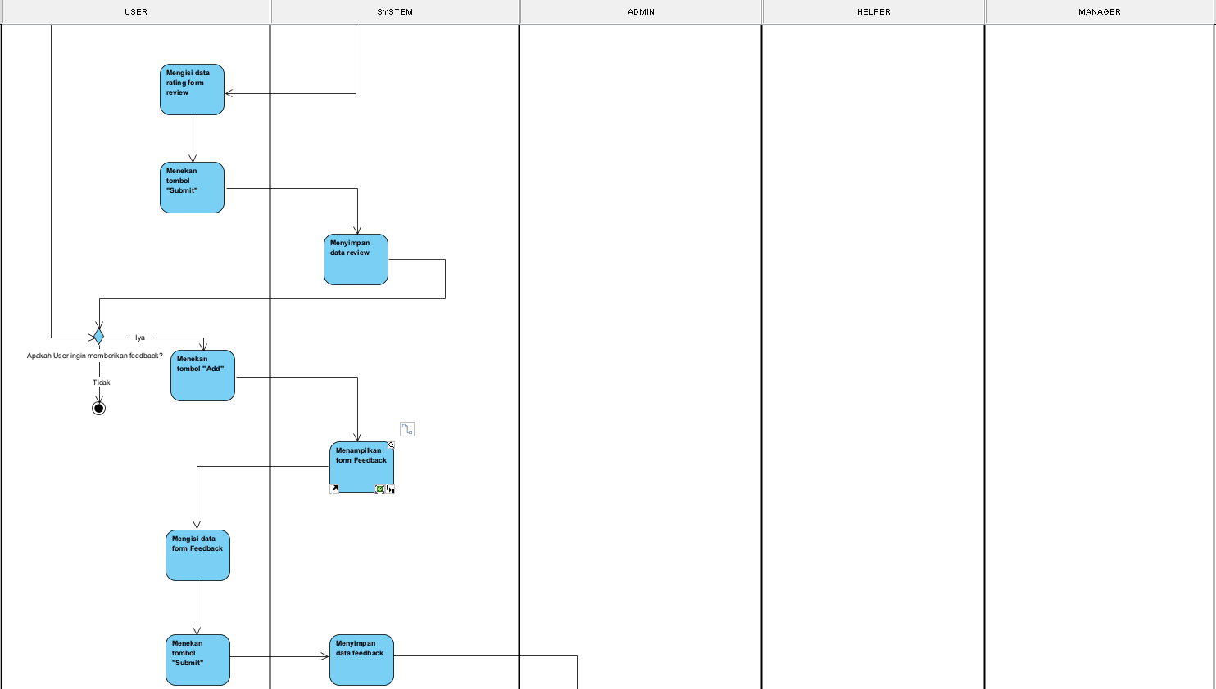

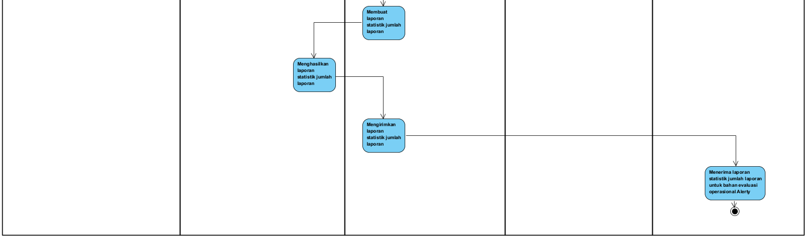

**2. Use Case**

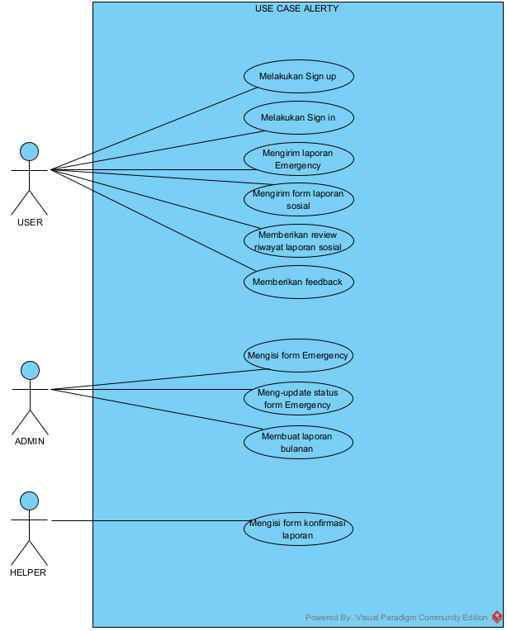

**3. Domain Class Diagram**

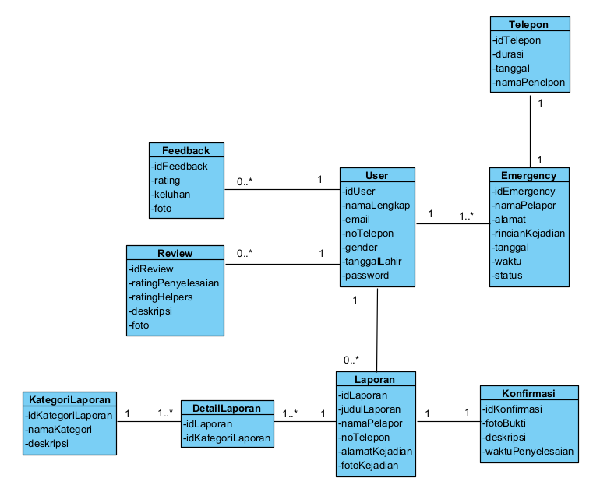

**4. State Machine Diagram**

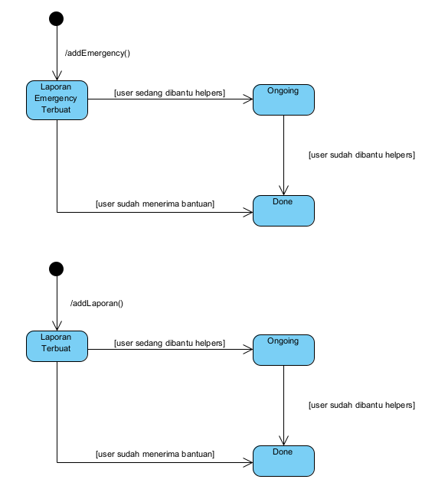

**5. Use Case Description**

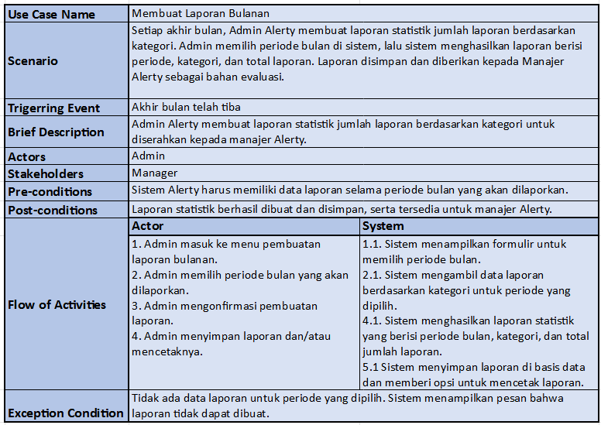

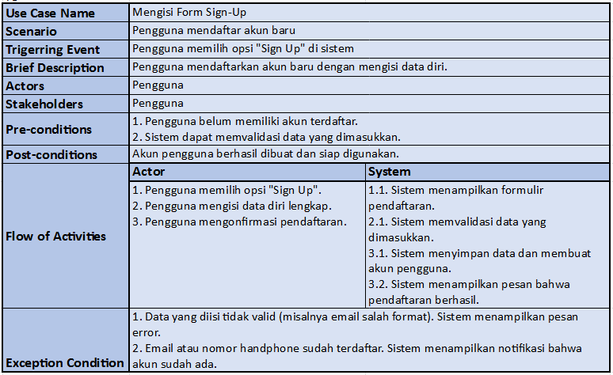

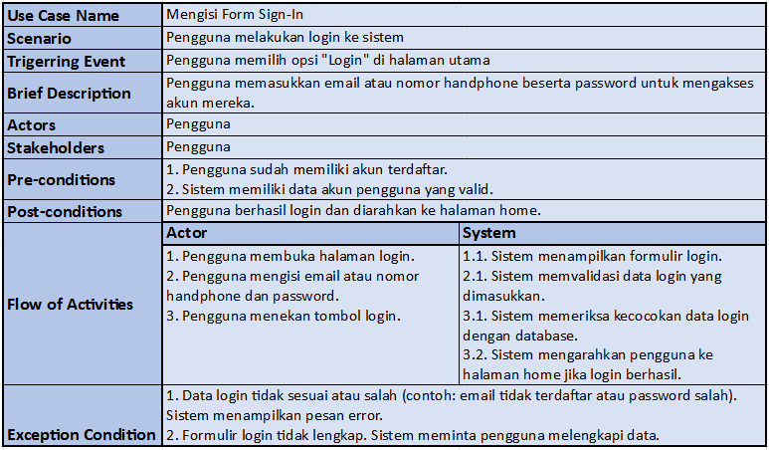

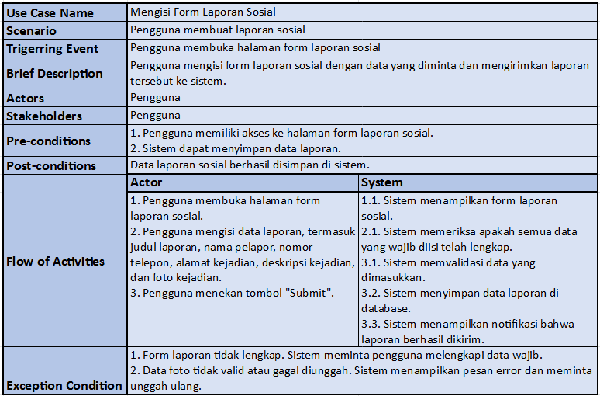

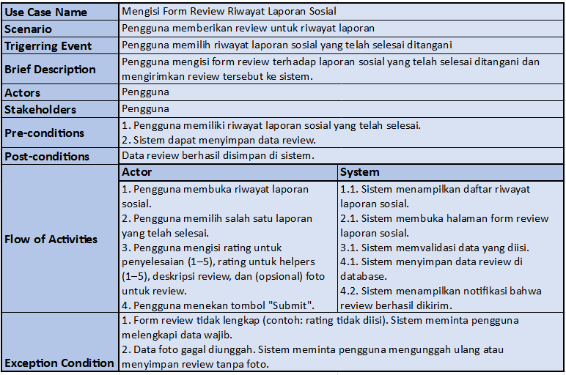

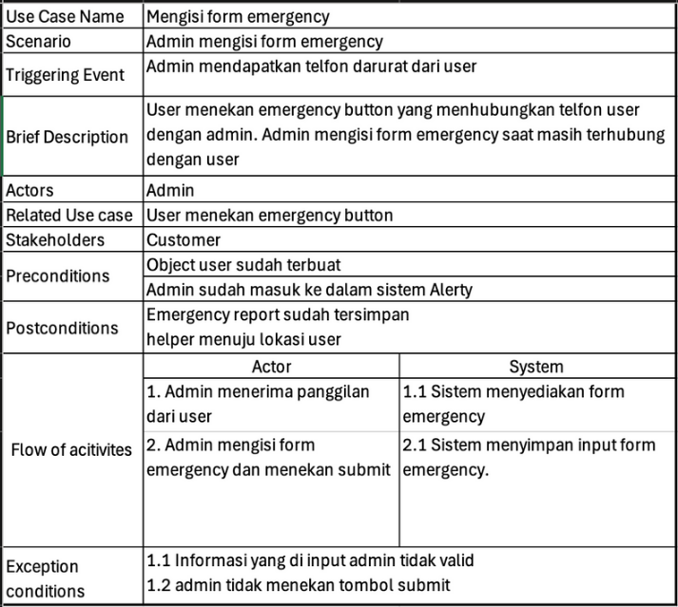

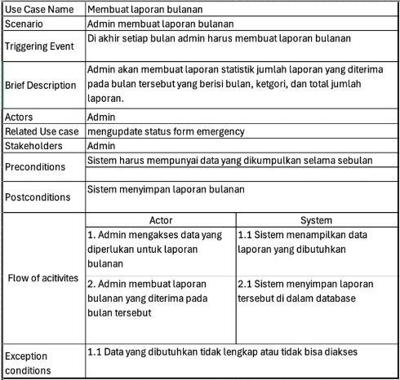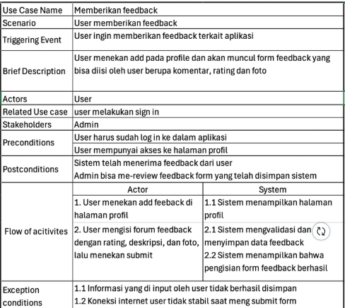

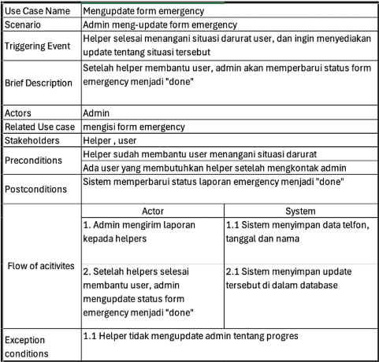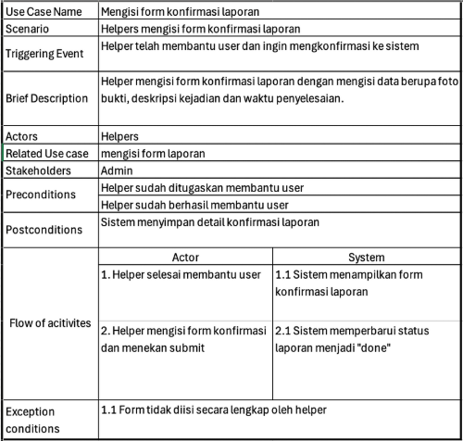

**6. Activity Diagram for Use Case**

**6.1 Melakukan Sign up**

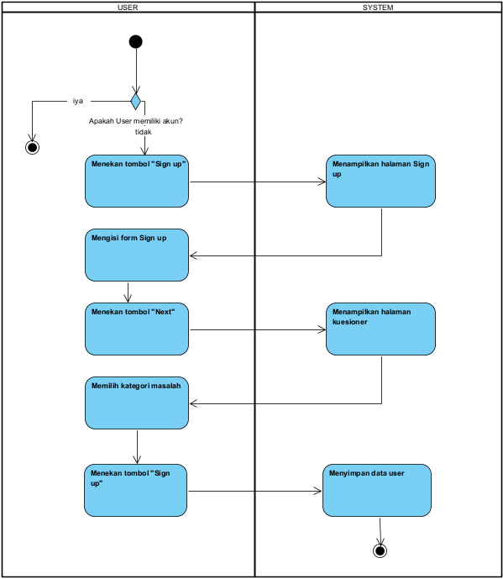

**6.2 Melakukan Sign in**

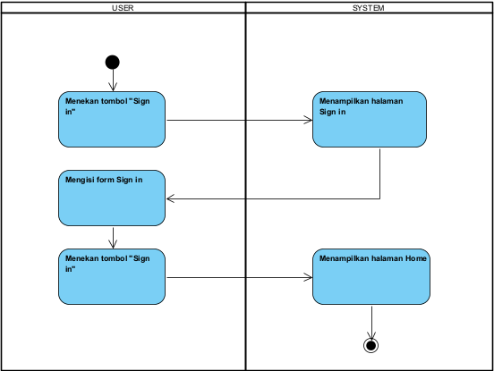

**6.3 Mengirimkan laporan Emergency**

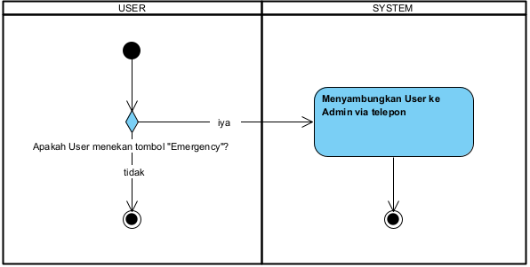

**6.4 Mengirim form laporan sosial**

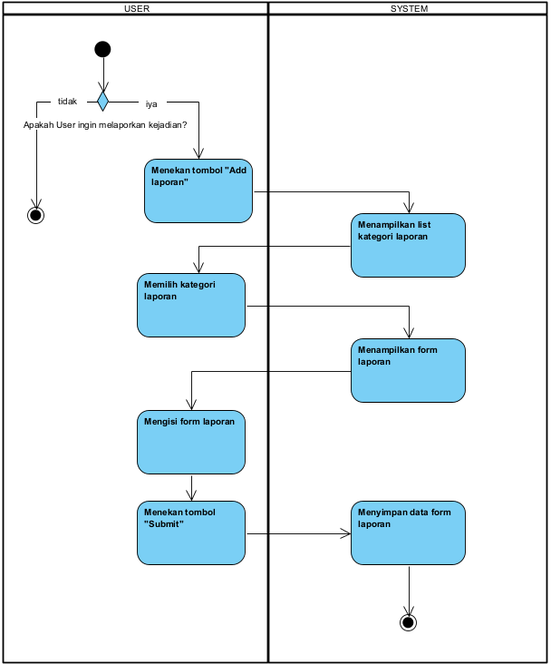

**6.5 Memberikan review riwayat laporan sosial**

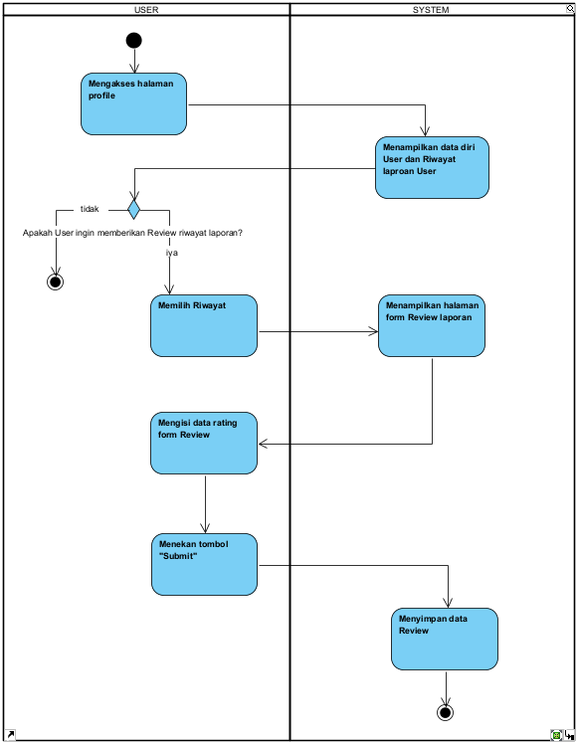

**6.6 Memberikan feedback**

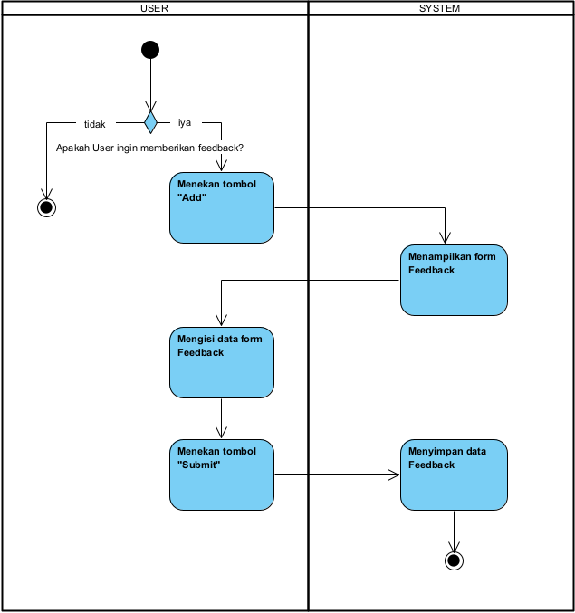

**6.7 Mengisi form Emergency**

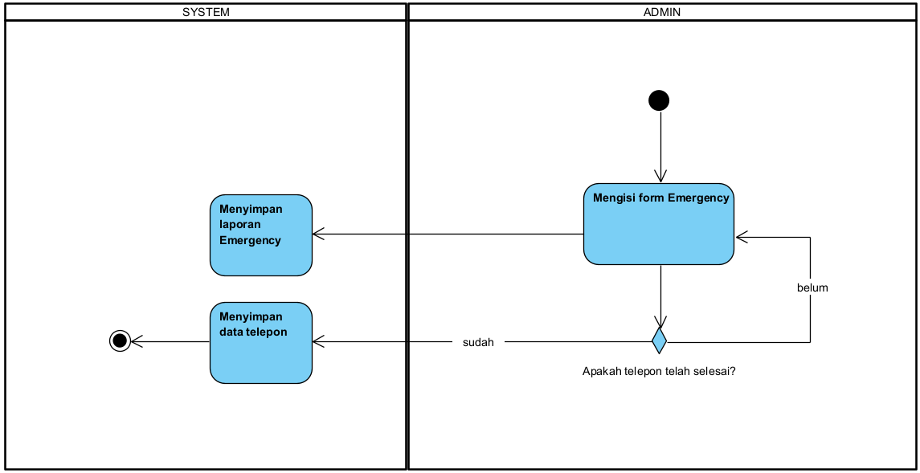

**6.8 Meng-update status form Emergency**

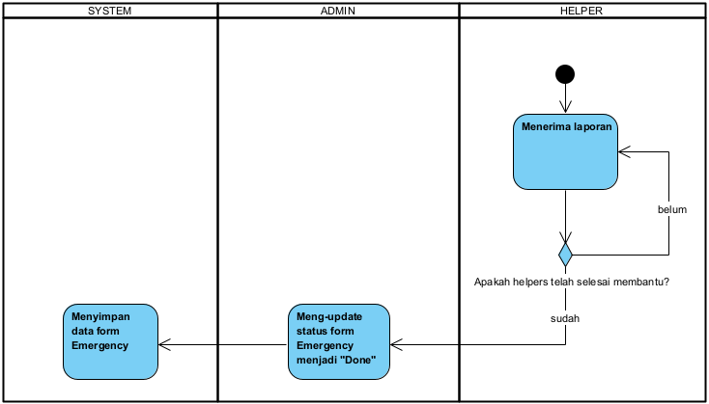

**6.9 Membuat laporan bulanan**

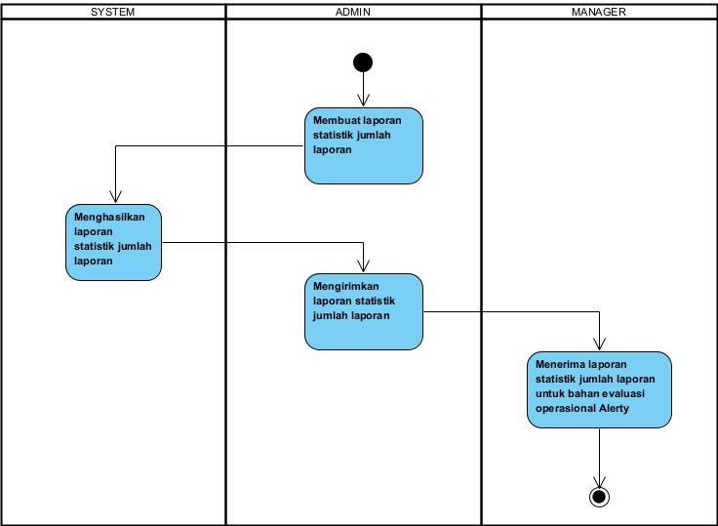

**6.10 Mengisi form konfirmasi laporan**

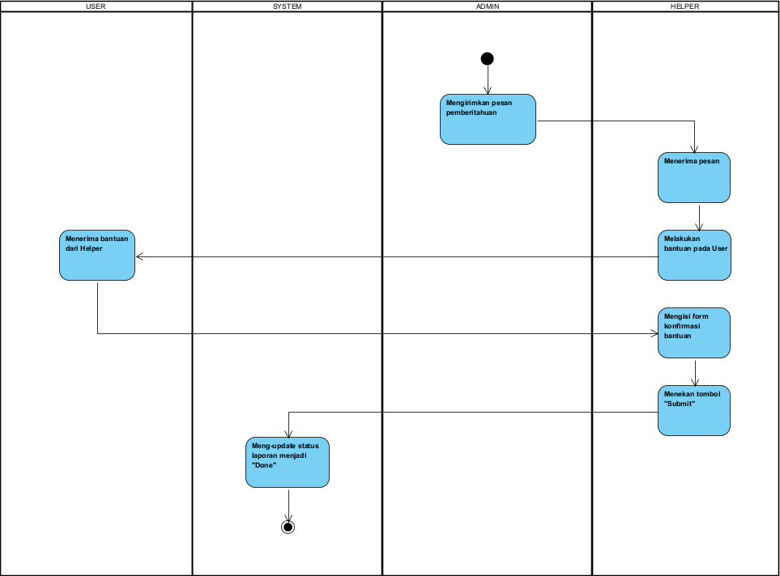

**7. Use Case: System Sequence Diagram**

**7.1 User : Melakukan Sign up**

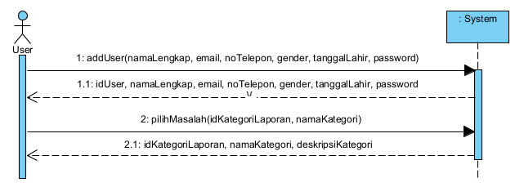

**7.2 User : Melakukan Sign in**

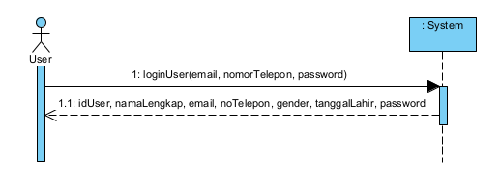

**7.3 User: mengisi laporan emergency**

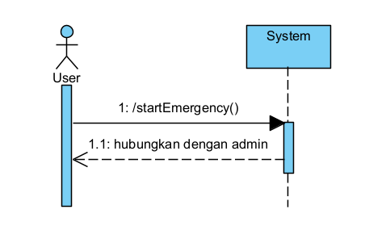

**7.4 User: Mengisi Form Laporan Sosial**

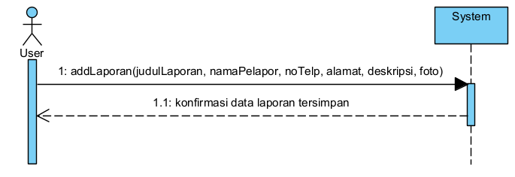

**7.5 User: Memberikan review riwayat laporan sosial**

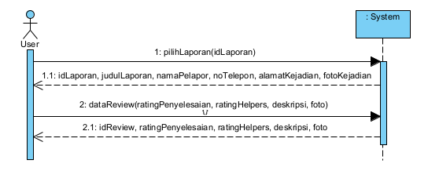

**7.6 User: Memberikan feedback**

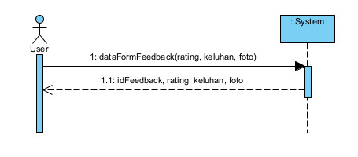

**7.7 Admin: Mengisi laporan Emergency**

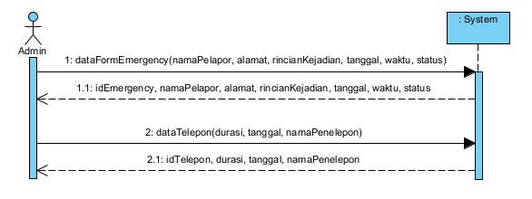

**7.8 Admin: Meng-update form Emergency**

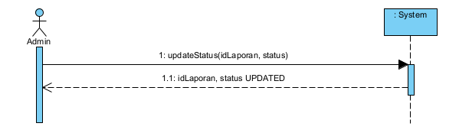

**7.9 Admin: Membuat laporan bulanan**

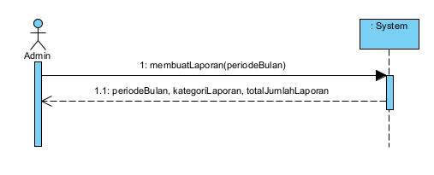

**7.10 Helper: Mengisi form konfirmasi laporan**

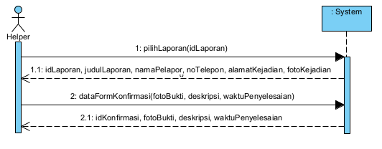

**8. Use Case and CRUD**



